Azure Monitor Workbook

Instructions to Import and Export a template

Installation Instructions:

Copy & paste the file content into the “empty” Azure Monitor Workbook, in “advanced edit” mode (press the </> icon). Please paste over any json that exists; it should tune to your subscriptions & workspace. You can have the file as an ARM template if you prefer.

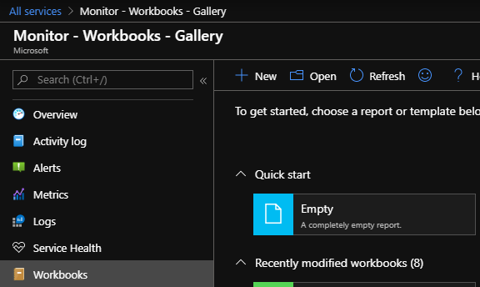

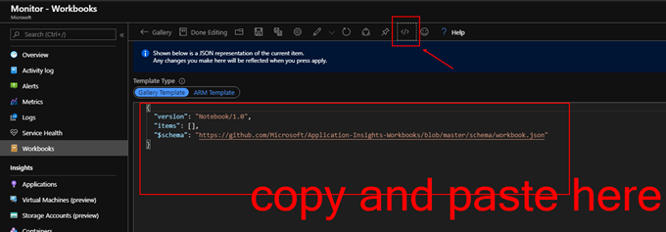

Then Press [apply] then [Done Editing]

Export Instructions:

You can choose JSON or ARM

